**UTHUKELA**

**DISTRICT DEVELOPMENT MODEL**

**ONE PLAN**

**2025**

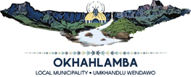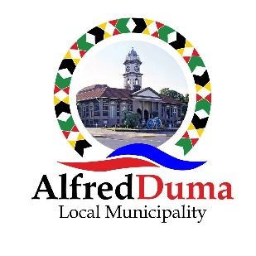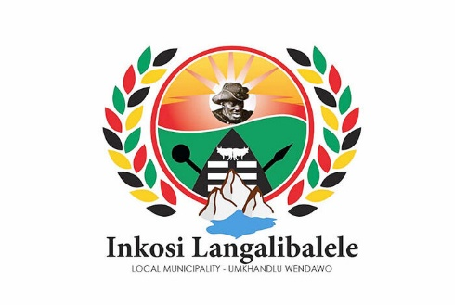****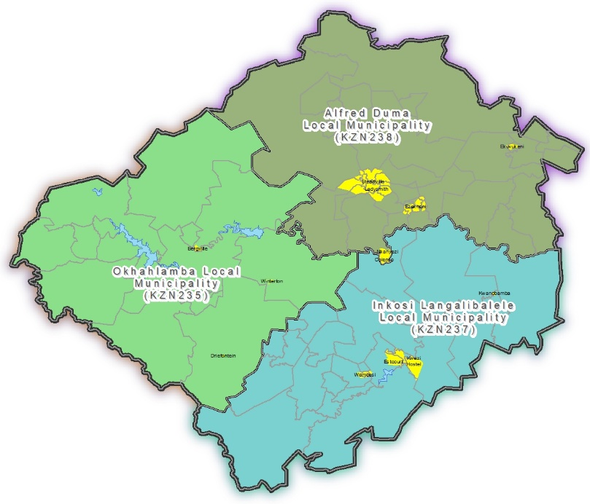

Contents

1. Background to the DDM and One Plan 6

1.1. One Plan Development 7

1.2. uThukela Approach to the DDM One Plan 8

2. uThukela District Perspective 9

3. Government Policy Overview 11

3.1. National Development Plan 11

3.2. Sustainable Development Goals 12

3.3. National Spatial Development Framework 14

3.4. 2035 Provincial Growth and Development Strategy (PGDS) 14

3.5. 2035 KwaZulu-Natal Provincial Growth and Development Plan (PGDP) 15

3.6. District Growth and Development Plan 16

3.7. Operation Sukuma Sakhe (OSS) 17

3.8. Strategic Infrastructure Projects (SIPS) 17

3.9. uThukela Integrated Development Plan (IDP) 18

4. Demographic Analysis 18

4.1. Education 19

4.2. Physical Health 20

5. Economic Analysis 21

5.1. Economic Drivers 23

5.1.1. Manufacturing Sector 23

5.1.2. Agricultural Sector 23

5.1.3. Tourism Sector 24

5.1.4. Service Sector 24

5.1.5. Government Sector 24

6. Infrastructure Analysis 24

6.1. Water infrastructure and sanitation 25

6.2. Waste Management 25

6.3. Transport Infrastructure 25

7. Spatial Analysis 26

7.1. Recovery Plans 30

8. Industrial Analysis 31

9. Agricultural Analysis 32

10. Service Provision 33

10.1. Water and Sanitation 33

10.2. Human Settlements 34

10.3. Waste Management 34

10.4. Electricity 35

10.5. Roads and Transport 35

10.6. Storm Water Management 35

11. Governance 36

12. Gender Based Violence 38

13. Existing Demographic Situation 38

14. SWOT Analysis 39

15. Vision 2050 40

16. Catalytic Projects 42

17. Strategic Goals 46

17.1. Transformational Area 1: Demographic Change/People Development 46

17.2. Transformational area 2: Economic Positioning 48

17.3. Transformational Area 3: Spatial Restructuring and Environmental Sustainability 50

17.4. Transformational 4: Area Infrastructure Engineering 52

17.5. Transformational Area 5: Integrated Service Provisioning 53

17.6. Transformational Area 6 – Governance and Management 55

18. Implementation, Monitoring, and evaluation 56

18.1. Monitoring and Evaluation 56

18.2. Key Performance Indicators and Targets* 58

19. Conclusion 64

List of Figures

*Figure 1: 2016 PGDP Strategic Goals and Objectives* 16

Figure 2: uThukela GVA 2010 - 2021 21

List of Maps

Map 1: uThukela District Municipality 10

Map 2: Tradition Areas and Wards of uThukela 11

Map 3: Transport Routes across all three local municipalities 26

Map 4: Settlements Patterns 28

Map 5: Nodes and Development Corridors 29

Map6: Catalytic Projects 45

List of Tables

Table 2: Age Structure of the Population 19

Table 3: Functional Literacy and Higher Education Attainment (20+ population), 2021 20

Table 4: Unemployment Rates per Local Municipalities, 2021 (uThukela SDF 2024) 22

Table 5: Household Current Income and Income Inequalities 23

Table 6: Water, 2016 33

Table 7: Sanitation, 2016 34

Table 8: War Room, Alfred Duma LM 36

Table 9: War Room, Okhahlamba LM 36

Table 10: War Room, Inkosi Langalibalele LM 37

Table 11: SWOT Analysis 39

Table 12: uThukela DM Catalytic Projects 42

Table 13: Monitoring Elements per transformational area 56

Table 14: Outcomes, Outputs, Key performance indicators and targets 57

Abbreviations

ADA Agribusiness Development Agency

ADLM Alfred Duma Local Municipality

AG Auditor General

CFO Chief Financial Officer

CSIR Council for Scientific and Industrial Research

CTO Chief Technology Officer

DDM District Development Model

DM District Municipality

DOE Department of Education

DALRRD Department of Agriculture, Land Reform and Rural Development

DWS department of Water Services

ECD Early Childhood Development

EDTEA Economic Development, Tourism and Environmental Affairs

ESID Economic Sectors and Infrastructure Development

EXCO Executive Committee

GIS Geographic Information System

GBV Gender Based Violence

GVA Gross Value Added

HH Household

IDP Integrated Development Plan

IGR Intergovernmental Relations

KZN KwaZulu Natal

KZN COGTA KwaZulu Natal Cooperative Governance and Traditional Affairs

KZN DARD KwaZulu Natal Department of Agriculture and Rural Development

KZN DOT KwaZulu Natal Department of Transport

LED Local Economic Development

MDGs Millennium Development Goals

NDP National Development Plan

NSDF National Spatial Development Framework

OSS Operation Sukuma Sakhe

PGDP Provincial Growth and Development Plan

PGDS Provincial Growth and Development Strategy

SAPS South African Police Services

SASSA South African Social Security Agency

SDF Spatial Development Framework

SETA Sector Education and Training Authority

SEZ Special Economic Zones

SIPS Strategic Infrastructure Projects

SMME Small, Micro and Medium Enterprises

TBD To Be Determined

TVET Technical Vocational Education and Training

UEDA

UTDM uThukela District Municipality

WSA Water Service Authority

# Background to the DDM and One Plan

The **District Development Model (DDM)** is an operational model for improving cooperative governance with the aim of building a capable, ethical, and developmental State. The DDM is viewed as a comprehensive approach to development planning and implementation that focuses on promoting collaboration, coordination, and inclusive governance at district level. Its goal is to address past inequalities and imbalances caused by apartheid-era spatial planning by bringing together government departments, local government, community representatives, traditional leaders, and other stakeholders to work collectively on development initiatives. The DDM One Plan seeks to shift the focus from isolated and fragmented development efforts to a more integrated and collaborative approach, creating sustainable and inclusive development within districts.

The **DDM** aims to transform the economy and improve the quality of life of people by enhancing cooperative governance. It has the following strategic goals:

* To respond strategically to socio-economic challenges.
* To stimulate a new thinking in the socio-economic paradigm.
* To fundamentally instil change in people development, the economy and space
* To develop the resilience and prosperity of the Country.
* To facilitate Responsive Institutions and Change Management; and
* To embed a Programmatic Approach to Cooperative Governance.

The District Development Model (**DDM**) Objectives are to:

* Address horizontal and vertical Silos in planning and implementation through the development of the “One Plan”.
* Narrowing the distance between communities and the government by strengthening the coordination role and communication channels at district and local levels.
* Strengthen monitoring and evaluation at the district level.
* Ensure inclusivity through community-responsive budgeting, based on the needs and aspirations of communities at local level.
* Foster a balanced and resilient approach towards development in urban and rural areas.
* Ensure sustainable development whilst accelerating initiatives to eradicate poverty, unemployment, and equality.
* Exercise oversight over budgets and projects.

The above is achieved through the development of a “**One Plan**” which is a long-term strategic framework that has a transformative approach to planning, focusing on demographic change, economic positioning, spatial restructuring and environmental sustainability, infrastructure engineering, integrated service provisioning, and governance and financial management within the sphere of district and metropolitan spaces.

The “**One Plan**” embodies a standardised approach where all three spheres of government and state entities, work together in an impact-oriented manner. This plan helps stakeholders to plan, budget and implement projects and programmes, and ensure that the work of role-players is managed and monitored towards a unified goal. The DDM One Plan Development Process is as follows:

* 1. **Diagnostic stage:** Analyse and understand the existing socio-economic development context.
  2. **Vision setting stage:** Setting a desired future, framed by national, provincial and regional development goals, clear outcomes and impacts.
  3. **Strategy formulation stage:** Identify strategies and interventions required to realise the desired future.
  4. **Implementation commitment stage:** Makes provision for the commitments and contributions of each sphere of government, state-owned entity, and private sector that will enable the identified strategies to be implemented.

## One Plan Development

The One Plan is a long-term, 25–30-year plan based on the **DDM Theory of Change,** providing a strategic framework to guide state and private investment. The One Plan should be visionary and investigate the following six (6) Transformational Areas to formulate a strategy as to how to transform each Transformational Area:

1. **Demographic Change/People Development** – a process of understanding the current population profile and development dynamics to reach a common and deeper understanding of the current demographic composition.
2. **Economic Positioning** – a process of creating a competitive edge to attract domestic and foreign investment and job creation. The economic positioning informs the spatial restructuring that is required.
3. **Spatial Restructuring and Environmental Sustainability** – a process of transforming spatial development pattern to stimulate local economy and create sustainable integrated human settlements. Spatial restructuring informs the importance of infrastructure investment and the location and layout of infrastructure networks.
4. **Infrastructure Engineering** – a process of bulk infrastructure planning and investment to support spatial transformation. This requires alternative forms of labour-intensive infrastructure projects, such as paving of artillery, ring and local roads.
5. **Integrated Service Provisioning** – a delivery process of integrated human settlement and municipal and community services in partnership with communities. This requires holistic household-level service delivery in the context of a social wage, job creation and improved livelihoods.
6. **Governance** – a process of enforcing leadership and management principles for effective, efficient, accountable and transparent planning, budgeting, procurement and performance management.

## uThukela Approach to the DDM One Plan

The uThukela approach to the DDM and the development of a One Plan is two-fold. Firstly, the DDM One Plan needs to reflect a few Catalytic Projects that will transform the District and make it more attractive to investors. Secondly, the plan will focus on the six transformational areas, and come up with strategies, interventions and commitments by stakeholders to transform the District.

It is envisaged that general matters outside the DDM One Plan, such as issues raised by the OSS War Rooms, will be addressed in Cluster meetings, where such matters will be discussed, resolved or actioned and reported upon at the next meeting.

Each of the six Transformation Areas will be evaluated to articulate the following:

* The Current Situation
* The Desired Future or vision
* The Strategies and Interventions needed to move from the Current to the Desired
* The Implementation Commitments by spheres of government and stakeholders
* Implementation, monitoring and evaluation measures and mechanisms.

# uThukela District Perspective

uThukela District Municipality is one of ten district municipalities within the Province of KwaZulu-Natal (KZN). The uThukela District Municipality derives its name from the major river originating from the Drakensberg mountains located along the western boundary of the Province with Lesotho. The Thukela River supplies water to a large portion of KZN, as well as Gauteng via a water transfer scheme. The District is bordered by three KZN district municipalities, namely Amajuba, uMzinyathi and uMgungundlovu and Thabo Mofutsanyana in the Free State Province towards the north-west. The district has two national routes (N3 and N11) running through the District, which are busy inter-provincial transport corridors.

Alfred Duma is the largest local municipality, followed by Okhahlamba and Inkosi Langalibalele. The District is 75% rural with larger areas comprising of traditional authorities. According to the 2022 National Census, the total population in the District is 789 092 people, up from the 668 072 in 2011, consisting of 172 197 households, spread unevenly among the seventy-six (76) wards. The dependency ratio is 57.5 and the average household size is 4.6. The District is dominated by females at a ratio of 46.6% males and 53.4% females, 84.1% of the population lives in formal dwellings and 40.7% have access to piped water inside their dwellings.

The uThukela DM is approximately 11 500 km² in extent and consist of three local municipalities, namely: Alfred Duma, Inkosi Langalibalele and Okhahlamba, with populations of 415 036, 230 924 and 143 132 respectively.

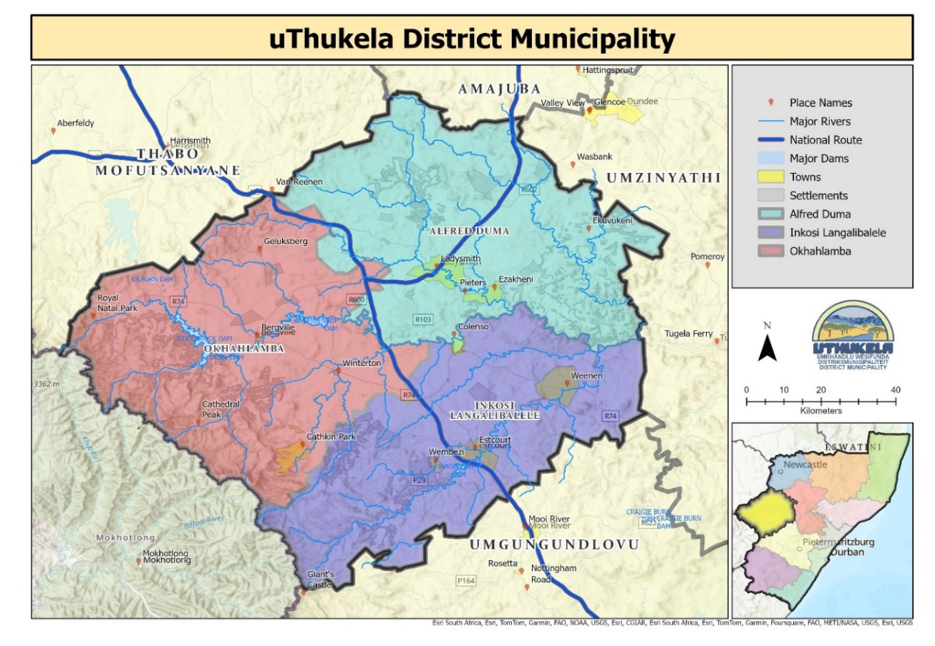

Map 1: uThukela District Municipality

Map 2: Tradition Areas and Wards of uThukela

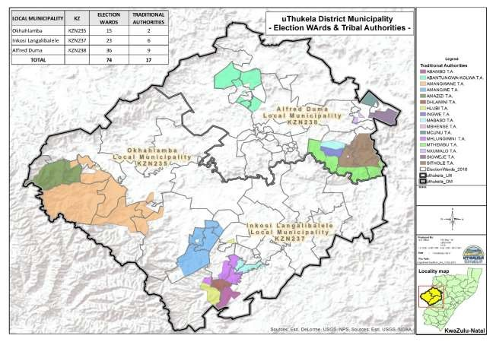

# Government Policy Overview

## National Development Plan

The National Development Plan (NDP) aim was to respond to South African’s aspirations and ensure inclusive economic growth through development. In May 2010, the National Planning Commission was appointed to create a vision and National Development Plan for South Africa. The NDP spans 15 chapters, addressing major topics, and provides recommendations and an implementation framework. South Africa must find ways to urgently reduce high levels of youth unemployment and provide young people with a broader range of opportunities.

The National Development Plan set out the following objectives:

* Create regional water and wastewater utilities and expand mandates of the existing water boards.
* Promoting social compact to reduce poverty and inequality and increase employment.
* Increased investment in new agricultural technologies, research, and the development of adaptation strategies for the protection of rural livelihoods and expansion of commercial agriculture.

The National Development Plan requires the local government to play a meaningful and active role in ensuring the implementation of the vision 2030. The plan compels the local government to be **service delivery oriented** in ensuring that the following is achieved:

* A comprehensive management strategy including an investment programme for water resource development, bulk water supply and wastewater management.
* Rural economies will be activated through improved infrastructure and service delivery, a review of land tenure, service to small and micro farmers, a review of mining industry commitments to social investment.
* Strong and efficient spatial planning system, well integrated across all spheres of government.
* Better quality of public transport and people living close to work and basic services.
* Improved safety.
* Develop a strategy for densification of cities and resource allocation to promote better-located housing and settlements.

## Sustainable Development Goals

Formerly known as the Millennium Development Goals, the Sustainable Development Goals 2030 was adopted on 25 September 2015. The aim of the Sustainable Development Goals 2030 was to end poverty, protect the planet, and ensure prosperity for all through 17 Sustainable Development Goals and 169 targets. The Sustainable Development Goals 2030 seek to realize human rights for all and to achieve gender equality and the empowerment of women and girls through the of sustainable development of the economy, society, and the environment.

The 17 Sustainable Goals are as follows:

* Goal 1 – End poverty.
* Goal 2 – End hunger, achieve food security, improved nutrition and promote sustainable agriculture.
* Goal 3 – Ensure healthy lives and promote well-being at all ages.
* Goal 4 – Ensure inclusive and equitable quality education and promote lifelong learning opportunities.
* Goal 5 – Achieve gender equality and empower women and girls.
* Goal 6 – Ensure availability and sustainable management of water and sanitation.
* Goal 7 – Ensure access to affordable, reliable, sustainable, and modern energy.
* Goal 8 – Promote sustained, inclusive, and sustainable economic growth, full and productive employment, and decent work.
* Goal 9 – Build resilient infrastructure, promote inclusive and sustainable industrialization and foster innovation.
* Goal 10 – Reduce inequality within and among countries.
* Goal 11 – Make cities and human settlements inclusive, safe, resilient, and sustainable.
* Goal 12 – Ensure sustainable consumption and production patterns.
* Goal 13 – Take urgent action to combat climate change and its impacts.
* Goal 14 – Conserve and sustainably use the oceans, seas, and marine resources.
* Goal 15 – Protect, restore, and promote sustainable use of terrestrial ecosystems, sustainably manage forests, combat desertification, and halt and reverse land degradation and halt biodiversity loss.
* Goal 16 – Promote peaceful and inclusive societies for sustainable development, provide access to justice for all and build effective, accountable, and inclusive institutions at all levels.
* Goal 17 – Strengthen the means of implementation and revitalize the Global Partnership for Sustainable Development.

To address the above goals, the district has programmes initiated such as poverty eradication programmes, sustainable economic growth, management of water and sanitation, and gender equality.

## National Spatial Development Framework

The National Spatial Development Framework (NSDF) seeks to make a bold and decisive contribution to bringing about the peaceful, prosperous, and truly transformed South Africa, as articulated in the Freedom Charter, the Reconstruction and Development Programme and the National Development Plan.

Important to the uThukela DM is the identification of Regional Development Anchors in the form of Ladysmith and Estcourt; Rural Service Centres scattered across the District and the N3 National Development Corridor that bisects the District. uThukela is classified as a National Eco-Resource Production Region and a Productive Agricultural Region, which makes it suitable for high-value agricultural land to support food security, as well as an Eco-Resource Production and Livelihood Region, which places the emphasis on the enhancement of productive capacity, cultural heritage, the environment, and natural resources.

## 2035 Provincial Growth and Development Strategy (PGDS)

The Provincial Growth and Development Strategy is aligned within the current provincial, national, and global policy frameworks, namely the six Provincial Priorities, the Twelve National Outcomes, the New Growth Path, the National Planning Commission’s Diagnostic Report and National Development Plan and the Millennium Development Goals (MDGs). The PGDS was not intended for Government only, but to secure buy-in and ownership with all developmental partners, being all spheres of government, state owned entities, business, higher education institutions, labour, civil society, and all other social partners. Being a framework for public and private sector investment, the PGDS can indicate areas of opportunities and development priorities, helping to address key issues of implementation blockages while providing strategic direction. It can also provide the district with better provision of infrastructure and services, restoring the natural resources, public sector leadership, delivery, and accountability, ensuring that these changes are responded to with resilience, innovation, and adaptability.

The vision of the PGDS: “*By 2035 KwaZulu-Natal will be a prosperous Province with a healthy, secure and skilled population, living in dignity and harmony, acting as a gateway to Africa and the World.”*

## 2035 KwaZulu-Natal Provincial Growth and Development Plan (PGDP)

The purpose of the PGDP is to translate the PGDS into an implementation plan. In this transition from strategy to plan, the focus is on driving implementation in a co-ordinated and integrated manner, where progress can be measured against predetermined targets and where roles and responsibilities have been confirmed within established lines of accountability.

Tertiary nodes are identified as Ladysmith and Estcourt and Rural Service Centres, spread across the District, are to have a combination of the following activities:

* Traditional administration centre
* Taxi / bus stop.
* Informal trading / market area
* Social facility (clinic, library etc.)
* Skills development centre (mainly local schools)
* Mobile services point (mobile clinics, pension pay points, mobile library etc.)
* Small commercial facility
* Recreational facility such as a sport field

The PGDS sets a goal of Annual District Unemployment Rate of 17% by 2035 from 26.7% in 2010 and 21.2% in 2015. This will require the increase of employment opportunities from 106 706 in 2010 to 221 152 in 2035. As with the PGDS, the PGDP was not drafted for implementation by government alone, but a whole range of stakeholders.

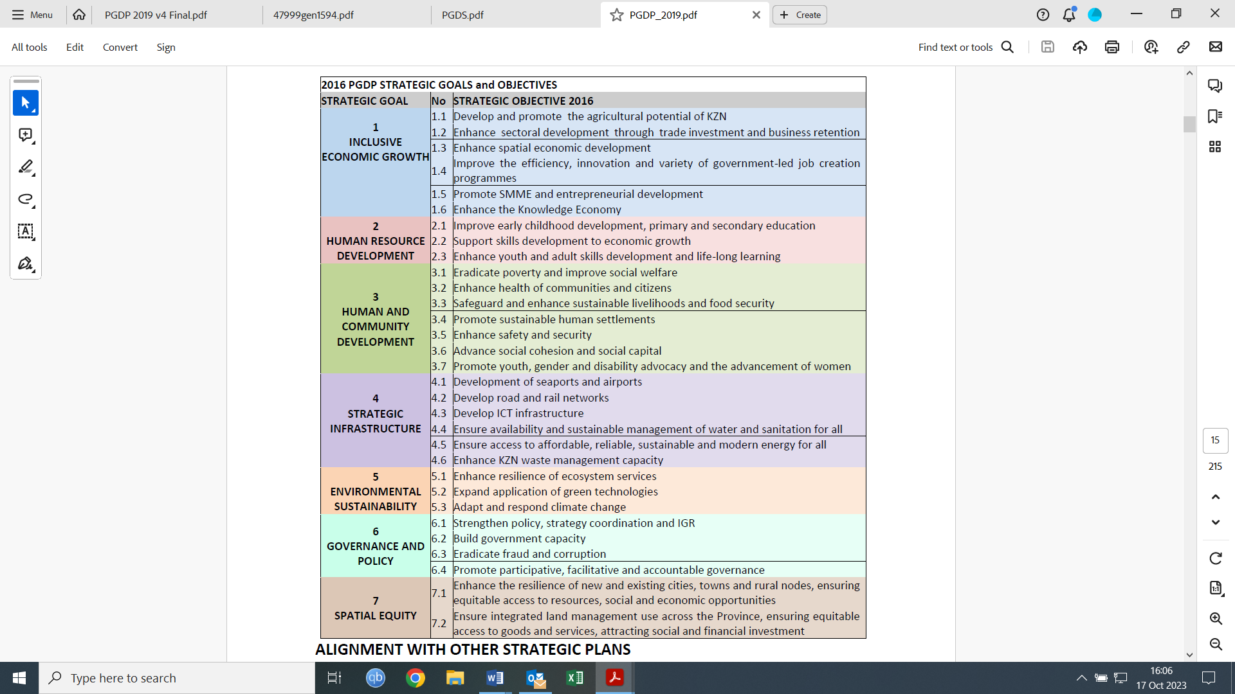

*Figure 1: 2016 PGDP Strategic Goals and Objectives*

## District Growth and Development Plan

The uThukela DGDP was adopted in July 2018. The District Growth and Development Plan (DGDP) was not intended to be a comprehensive all-encompassing development plan for the district, but rather a focus on strategic catalytic projects of high impact, that can fast-track interventions for accelerated and shared growth. Catalytic projects contained in the 2018 DGDP were carried forward to the first generation One Plan and the second generation One Plan, which was adopted on 28 February 2023. After the Presidential visit on 30 June 2023, the need was identified to review the catalytic projects, which will form part of this document.

## Operation Sukuma Sakhe (OSS)

Operation Sukuma Sakhe (OSS) was launched in March 2011, with the aim of integrating the services of government to fight poverty, combat social ills and promote healthy lifestyles, thereby creating a better life for all citizens. As a strategy, it aims to integrate departmental programmes and deliver jointly on outcomes to strengthen departmental cooperation in service delivery. It brings service delivery together at community and ward level under a WAR ROOM concept. It is important to keep in mind, that the District Development Model (DDM) is in essence an IGR structure, where OSS plays a central role.

Following from above, the following OSS Vision was formulated: “*Together with committed leadership, creating sustainable livelihoods, through the provision of integrated services to communities, promoting a better life for all*.”

OSS delivery model is designed to address the critical areas of community participation, integrated service delivery, economic empowerment, and environmental care.

## Strategic Infrastructure Projects (SIPS)

The SIPS was adopted with the intention to transform the economic landscape of the country, create jobs, and strengthen the delivery of basic services to the people. Then plan is based on an objective assessment of the infrastructure gaps through spatial mapping that analyses future population growth, projected economic growth and areas of the country that do not have access to water, electricity, roads, sanitation, and communication.

## uThukela Integrated Development Plan (IDP)

The 2023/2024 uThukela Integrated Development Plan refers of the implementation of the District Development Model and the One Plan One Budget approach. The following table indicates the relationship between the IDP and One Plan:

Table 1: Relationship between the IDP and One Plan

|  |  |
| --- | --- |
| IDP | One Plan |
| * 5-year plan linked to a long-term vision | * Long term plan with a 25–30-year vision |
| * Developed by the municipality and adopted by Council | * Coordinated through the DDM Structures and adopted by the Political Hub |
| * Implementation is the concern of the municipality. | * Implementation is the concern of all levels of government, including external role-players. |
| * Legislative requirement in terms of the Municipal Systems Act and defined development and review process through an adopted framework and process plan | * Not legislated |
| * Comprise of short to medium term service delivery programmes and projects | * Comprise of catalytic projects and government programmes at all levels |

# Demographic Analysis

According to the 2022 National Census, the total population of the District is 789 092 people, spread unevenly among the seventy-six (76) wards. The population aged between 0 and 14 is 36% and that of the working-age (15-64) is 58.7%, with the elderly population (65+) making up 5.2%. The working-age population is 59.2% in Alfred Duma, 59, 9% in Inkosi Langalibalele and 55, 9% in Okhahlamba.

Table 2: Age Structure of the Population

|  |  |  |  |  |  |
| --- | --- | --- | --- | --- | --- |
| Municipality | Children  (0-14) | Working Age | | Elderly  (65+) | Dependency Ratio |
| **Youth**  **(15-34)** | **Non-youth**  **(35-64)** |
| Alfred Duma | 35.5% | 34.3% | 24.8% | 5.3% | 0.44 |
| Inkosi Langalibalele | 35.2% | 34.6% | 25.3% | 4.9% | 0.44 |
| Okhahlamba | 38.7% | 32.8% | 23.1% | 5.4% | 0.40 |
| uThukela | **36.0%** | **34.1%** | **24.6%** | **5.2%** | **0.43** |

Source: *Quantec 2022*

***Age dependency ratio****: The ratio of persons aged under 15 and older than 64 to those aged between 15 and 64 years (working age).*

Alfred Duma holds the biggest share of the population of uThukela, at 50.8%, followed by Inkosi Langalibalele at 29.4% and Okhahlamba at 19.8%. Black Africans constitute 96.2% of the district population. The shares of other population groups are Coloured (0.5%), Indian/Asian (2.1 %), and White (1.2%). Males make up 47.2% of the population and Females 52.8%, which could possibly be to male jobseekers working outside the District.

The District has a total number of 172 197 households with 1 673 being child-headed households, 28% of which live in informal dwellings and subject to extreme poverty. Female headed households make up 52.7% of households. The CSIR demographic projection tool estimates the uThukela population, at a medium growth scenario, at 830 000 by 2030 and 880 000 in 2050. In a high-growth scenario, the district population will grow to 920 000 in 2030 and 1.04 million in 2050.

## Education

The functional literacy rate (population above 20) of the district is 67.5%, which is lower than the national and provincial averages of 77% and 74%, respectively. The functional literacy rate is highest in Alfred Duma LM (74%) and lowest in Okhahlamba LM (61%). The attainment of a higher education in the District is at 1.42 %, which is well below the national (4.30%) and provincial (2.61%) averages. The lowest level is in Okhahlamba (1.06%), followed by Inkosi Langalibalele (1.18%) and Alfred Duma (1.70%). The table below indicates the functional literacy and higher education attainment in the District as of 2021.

Table 3: Functional Literacy and Higher Education Attainment (20+ population), 2021

|  |  |  |
| --- | --- | --- |
| Municipality | Functional Literacy | Higher educational attainment (bachelor’s degree and above) |
| Alfred Duma | 70.9% | 1.70% |
| Inkosi Langalibalele | 65.6% | 1.18% |
| Okhahlamba | 60.9% | 1.06% |
| UTHUKELA | **67.5%** | **1.42%** |

Source: *Quantec 2022*

According to Department of Education, the matric results has shown an increase of nearly 14% from 74.6% in 2021 to 80.00 % in 2022.

## Physical Health

Certain infectious and parasitic diseases of the circulatory system and diseases of the respiratory system are some the main causes of death in the District. HIV/AIDS is the leading cause of death for the 15-34 and 25-64 age cohorts, at 18.7% and 22.3% respectively. uThukela has an estimated 22.4% of its people living with HIV/AIDS.

The top two leading causes of death for children below the age of five is diarrheal diseases (26.8%) and lower respiratory infections (17.0%). For the elderly, cerebrovascular disease, such as strokes (20.2%) followed by ischemic heart disease (13.2%) are the leading causes of death. The TB death rate within the District stands at 10 persons per quarter.

The leading causes of death for women in the 15-49 age category are due to indirect maternal conditions (34.3%) and other maternal conditions (22.2%). The Maternal Mortality Ratio (per 100 000 live births) is 140.2, with Alfred Duma municipality recording the highest at 205.3.

# Economic Analysis

Local economic development (LED) in uThukela is seen as one of the most important ways of reducing poverty. The district’s aim is to create jobs by making the local economy grow. The economy is developed unevenly across the district, with poverty present mostly in rural areas. Of concern are the number of smaller towns that are struggling to draw development, such as Weenen and Colenso, as well as other densely populated rural areas. Commercial farming is mostly practised around Bergville, Winterton and a small area around Weenen.

In 2010, Manufacturing contributed 21% to the Gross Value Added of the District, followed by 16% in the finance, business services and wholesale, trade, and accommodation sectors. In 2021 information released by EDTEA, places general government at 20.42%, and wholesale, trade, and accommodation at 16.56%, with Manufacturing making up 15.39% in terms of the district share of Gross Value Added. Manufacturing has therefore seen a drop of over 5% in ten years. The figure below indicates the shift of sectors in term of GVA over the last 10 years.

Figure 2: uThukela GVA 2010 - 2021

GVA, as a measure of prosperity, indicates a most noticeable and worrying drop in Manufacturing, and Finance, insurance, real estate and business sectors and the rise in the General Government sector, contributes to the perception of a sector that is overinflated and a burden to the tax base.

The overall unemployment rate in the District is 44%, which is much higher than the national (34%) and provincial (37%) averages. The level of unemployment is highest in Okhahlamba LM (48%), and lowest in Alfred Duma LM (42%), with Inkosi Langalibalele having an unemployment rate of 46%. The youth unemployment rate in the District is 60%, which is also much higher than the national (48%) and provincial (52%) averages. The high overall and youth unemployment rates indicate the lack of economic opportunities in the District.

Table 4: Unemployment Rates per Local Municipalities, 2021 (uThukela SDF 2024)

|  |  |  |  |
| --- | --- | --- | --- |
| Municipality | Overall Unemployment rate | Youth Unemployment rate (15-34) | Share of formal Employment |
| Alfred Duma LM | 41.99% | 57.7% | 84% |
| Inkosi Langalibalele LM | 46.24% | 63.0% | 83% |
| Okhahlamba LM | 47.58% | 62.2% | 78% |
| uThukela DM | **44.14%** | **60.0%** | **82%** |

*Source: Quantec, 2022*

The average household income in the District is about R214 000 per annum, which is lower than the National (R272 500) and Provincial average (R259 600). With 62.7% of the population is living in poverty, uThukela is amongst the 10 worst performing districts. The overwhelming majority of people living in poverty are from black communities.

The Gini coefficient measures the level of income inequality, with a Gini coefficient of zero expressing equality, and the value 1 represents inequality. Both South Africa and uThukela have a Gini coefficient of 0.630, the highest in the world. The table below indicates the average household income, taxation, and Gino Coefficient per LM.

Table 5: Household Current Income and Income Inequalities

|  |  |  |  |
| --- | --- | --- | --- |
| Municipality | Average HH income | Tax paying population | Gini Coefficient |
| Alfred Duma | 221 110 | 0.2% | 0.607 |
| Inkosi Langalibalele | 223 680 | 2.8% | 0.611 |
| Okhahlamba | 179 720 | 1.8% | 0.598 |
| UTHUKELA | **214 040** | **1.6%** | **0.630** |

Source: *Quantec 2022*

## Economic Drivers

Community services consistently dominate as an employment sector in two local municipalities, except in Alfred Duma where manufacturing is on par with community services. Ladysmith is the economic hub of uThukela and dominates the spatial economy of the District. Manufacturing is mostly concentrated in Ladysmith but there are some industrial activities located in Estcourt. Okhahlamba has a window of opportunity to improve the agricultural and tourism economies.

The District Economic Profile for uThukela, 2021 by the KZN Department of Economic Development, Tourism and Environmental Affairs highlights the following Economic Drivers.

## Manufacturing Sector

Ezakheni was established as an industrial decentralisation point in the late 1960s. following the removal of government subsidies, around 50% of the more marginal companies closed. However, since then the number of operational companies at Ezakheni has increased due to the accessibility to land, railroad, and utility services.

## Agricultural Sector

Agriculture is an important contributor to the economy of uThukela and the sector is well known for wheat, maize, soya, and potato production. Large areas of commercial agricultural is set aside for land reform and land claims are in various stages of completion. The result is a loss in land to agricultural production, unless leased back to commercial farmers.

## Tourism Sector

The tourism sector comprises the berg experience with hotels, chalets, and camp sites; historical tourism involving battlefields routes; and the wildlife experience in the form of proclaimed and private conservancies, which includes areas devoted to game farming and professional hunting. Adventure tourism is linked to the berg and bush experience.

## Service Sector

This sector contributes substantially to the district economy. Higher order commercial services are provided in Ladysmith, Estcourt, Bergville and Winterton, while smaller commercial centres are in Weenen and Cathkin Park.

## Government Sector

The government sector has regional offices mainly at Ladysmith with sub-offices in the other parts of the district. Government departments provide the full range of social and welfare services to communities via these offices. Owing to the scale and extent of the government sector in the district it makes a significant contribution to employment and the economy of the District, as well as monies in the form of pension and welfare grants.

# Infrastructure Analysis

The process by which infrastructure planning and investment especially bulk infrastructure installation occurs to support the transforming spatial pattern and form, meet the needs of a competitive and inclusive local economy and integrated human settlements, and ensure demand for housing and services is met in a sustainable and resilient way long term.

## Water infrastructure and sanitation

uThukela District Municipality is a Water Service Authority (WSA). The core mandate of uThukela is the provision of water and sanitation services, where the main objective is to provide clean and safe drinking water in the region. The primary objective is to extend portable water and sanitation services throughout the district by eliminating the backlogs and to maintain and ensure sustainability of the existing water and sanitation infrastructure.

## Waste Management

Waste management is a shared function between the district and local municipalities, where the district is responsible for the establishment, operation, and control of district wide waste disposal sites and this must be accessible to more than one local municipality.

Access to refuse removal remains a problem in the district, particularly Okhahlamba. The district has an Integrated Waste Management Plan where it provides strategies to address the backlogs in refuse collection, both at district and local level. The plan also focuses on describing two categories of waste namely general waste and hazardous waste.

## Transport Infrastructure

The District’s road hierarchy can be classified in three categories, namely National, Provincial, District and local roads. uThukela is mainly served by two corridors. These corridors are the N11 national route that connects the N3 with Mpumalanga Province coal mining areas and the N3, which connects two of the country’s most economically active metropolitan areas namely Gauteng and Durban.

Although the District has one of the best industrially orientated rail systems, currently all rail facilities in the municipality are under-utilised, with approximately 55 trains running through Ladysmith station daily. Rail passenger services are limited to between 3 - 4 trains operating between Durban and Johannesburg 3 days a week. As a result, increased reliance by industry on road transport has placed increased pressure on the road network.

# Spatial Analysis

Spatial structuring elements that influence the current settlement pattern and typology of the district includes natural environment features such as mountains, water bodies, protected areas, and high existing and potential agricultural land, built environment structures elements such as settlements, roads, and railway lines. The uThukela District Municipality is bordered by three other district municipalities, namely, Amajuba, uMzinyathi and uMgungundlovu and Lesotho to the south-west and the Free State Province to the north-west.

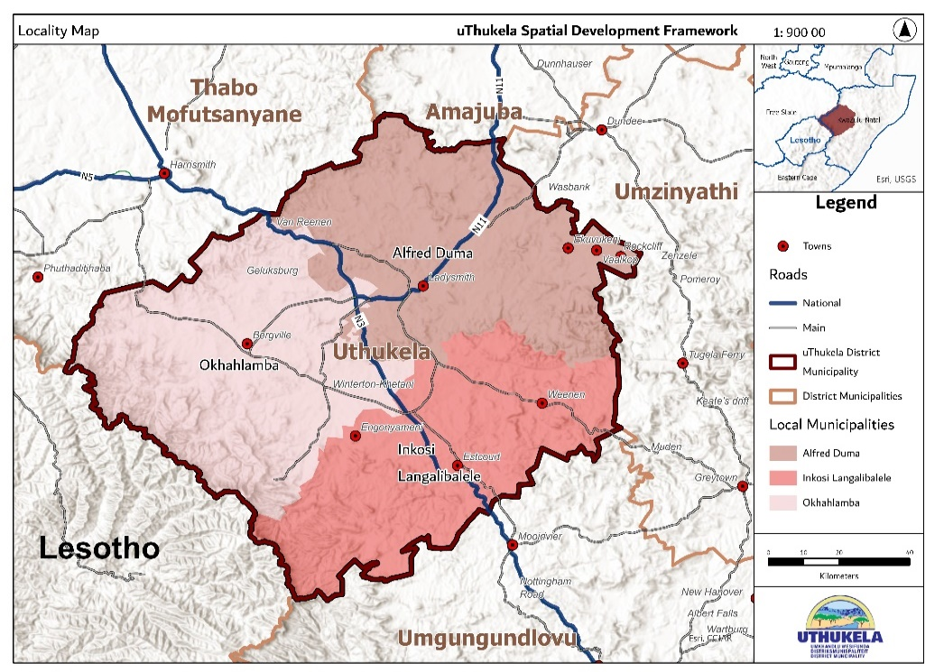Two national highways, the N3 and the N11, transects the municipal area, the N3 linking Durban with Johannesburg being a busy national corridor of immense importance. Alfred Duma municipality dominates the spatial structure of the district as the main core/nucleus, which is important to consider when planning for development.

Map 3: Transport Routes across all three local municipalities

The 2022/2023 uThukela DM SDF recognises the following broad land use categories and settlement patterns as depicted in the following map:

* Urban nodes are Ladysmith, Colenso, Ezakheni, Estcourt, Wembezi, Weenen, Bergville, Winterton and Ekuvukeni.
* Important commercial nodes are Ladysmith and Estcourt, with Bergville and Winterton being more locally centred.
* Commercial agricultural areas are mostly found around Bergville and Winterton and a smaller area around Weenen. Pockets of good agricultural land can also be found around the Wasbank, Bramhoek and Wagendrift Dam areas.
* There are several Traditional Areas with dense rural settlement spread across the District and some rural settlement areas that are not proclaimed traditional areas, such as Driefontein, Matiwaneskop, Jononoskop, Lucitania, Nkunzi, Frere, Chiveley, Cornfields and Thembalihle.
* Conservation areas include the Ukhahlamba Drakensberg Park World Heritage Site, nature reserves, such as: Weenen, Wagendrift and Moor Park, private game farms and heritage sites.

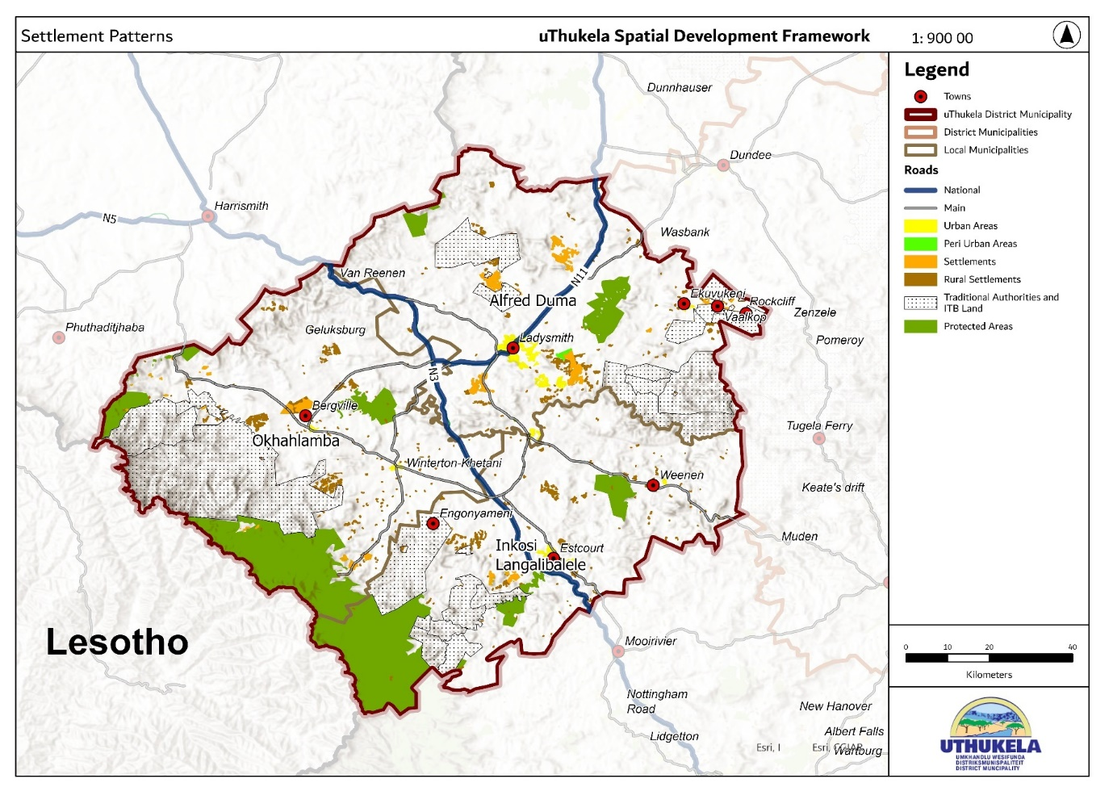

Map 4: Settlements Patterns

The dominant land use within uThukela is commercial agriculture, which covers 6 852 km2 or 60% of the geographic area of the district. Settlements represent 2% of the land uses in uThukela. The traditional authority areas account for 18% (2 078 km2) of the District. Settlements that are significant in size but not formalised urban areas, include: Driefontein, Matiwane and Roosboom, which is to the south of Ladysmith. Other smaller settlements are scattered within the municipal landscape and include: Lucitania, Blue Bank, St. Joseph’s Mission, Droogval, Steincoal Spruit (Nkunzi) and Van Reenen.

Tourism Nodes are primarily located in Cathkin Park, Babangibone, Giants Castle and Injisuthi, and some historical sites are located around the wider Ladysmith area. The uKhahlamba-Drakensberg Park is a protected area, spanning 2 428.13 km2 and is part of the Maloti-Drakensberg Park, a World Heritage Site. A substantial portion of the Park is in uThukela DM.

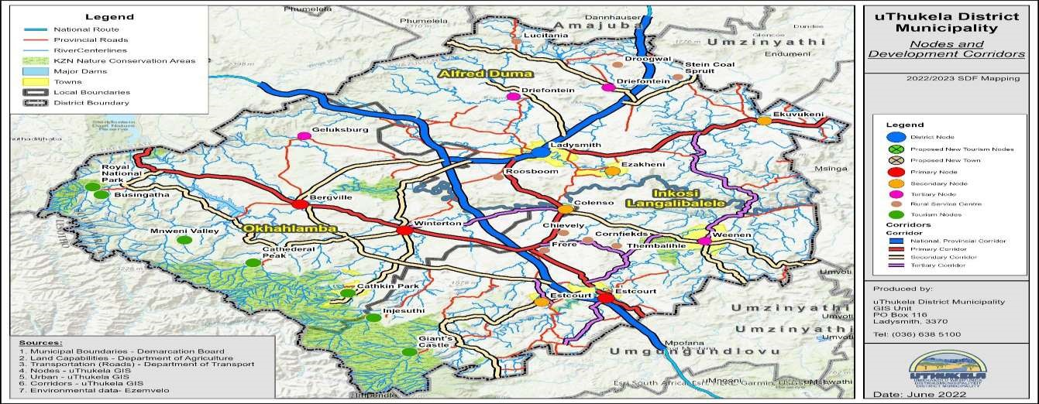

Map 5: Nodes and Development Corridors

The Draft 2023 uThukela SDF, states that the spatial goals of the District are to address spatial challenges and in doing so will focus on development towards:

* Exploring and maximizing the district’s inherent economic opportunities.
* Protection and utilization of resources such as its tourism assets, rich agricultural land, and diverse natural environment.
* Development of sustainable settlements where residents can lead enriched, healthy, and convenient lives; and
* Social change through the delivery of basic services, improved connectivity, and cultural diversity.

The uThukela District Municipality formulated the following Spatial Vision:

“*uThukela will be a spatially efficient district, with a robust economy, conserved environment, and sustainable social life”.*

From this vision, six spatial objectives were formulated:

* Develop and maintain a viable built environment.
* Improve connectivity and movement systems.
* Sustainable Economic Development and Concentration.
* Upgrading and maintenance of the District Infrastructure.
* Protect and conserve the District’s natural environment and assets.
* Rural Development and Transformation.

## Recovery Plans

Although the District has recovered from the Covid-19 pandemic, various offerings in the form of dams, water, good agricultural land, the Drakensberg, the Anglo-Boer war history, and other tourism offerings have been realised. The following opportunities are worth exploring:

* Business Investment and Retention Policies were initiated by local municipalities.
* Expansion of the RASET and Agri-Park initiatives across the District.
* Establishment of Business Forums in Okhahlamba and Inkosi Langalibalele to be grown to Business Chambers and possibly amalgamated into a District Forum or Chamber
* Facilitate the implementation of the Gas-generated electricity project at Colenso.
* Establishment of a Textile SEZ in Ladysmith.
* Implementation of the Estcourt, Weenen Nodal Plan.

Some short-term Interventions by the uThukela Economic Development Agency (UEDA) based upon the above opportunities were also realised:

* To facilitate the completion of Local Municipal Business and Retention Policies.
* Unblock hindrances to RASET implementation and expansion.
* Establishment of the Okhahlamba and Inkosi Langalibalele Business Forums.
* Monthly Progress Reports to the uThukela DM Economic Portfolio.

Sector specific strategies and programmes to address the uThukela District economic include the following:

* Strategy 1: Develop and support the tourism sector.
* Strategy 2: Expand the agricultural sector.
* Strategy 3: Support the informal economy and small enterprises.
* Strategy 4: Expand and diversify the manufacturing sector.
* Strategy 5: Improve the LED institutional capacity and policy environment.
* Strategy 6: Ensure effective education, skills, and capacity development.
* Strategy 7: Expand and develop strategic economic infrastructure.

# Industrial Analysis

Industries in uThukela DM are not only located overwhelmingly in Ladysmith, but also in Estcourt and in smaller towns. The 5% drop in manufacturing in 10 years, indicates ta sector that has diminished, however some recent investments, such as CMT has been welcomed. The sector is plagued by constant breaks in electricity, as well as water and sanitation provision. Despite these constraints, the following investments are underway or eminent:

* Sumitomo Rubber (Dunlop): Technological upgrade to the value of R1.7 billion.
* Defy: National investment of R288 million, with a portion to be allocated to the uThukela factory.
* Nestlé: Nesquik discontinued due to a drop in sales and lower demand, possibly linked to higher prices due to sugar-tax. No job losses due to restructuring of operations.
* CMT Pro-textile R450 million investment, will be the biggest dye house in Africa.

The poor water and sanitation service delivery from uThukela DM has been cited as a contributing factor for loss of production, and only through external interventions have companies been able to survive and remain within the District. Aging infrastructure, the lack of turnaround time to address faults and the general unwillingness to address issues is posing a serious threat to industry and employment in uThukela. Not investing in infrastructure, nor addressing infrastructure issues are damaging the image of uThukela and investor confidence.

# Agricultural Analysis

Much of the District’s non-urban land is used for grazing, however there are small areas used for cropping, such as Besters and the Sunday's River irrigation scheme. The main commercial cropping areas are located around Winterton and Bergville and a small area located near Weenen. Timber production area also located along the southern Drakensberg area. Game farms and reserves are spread across the District, with a concentration between Ladysmith, Weenen, and Estcourt. Formal Game Reserves are located around government dams and the Drakensberg. Game Reserves are mostly located on land where the vegetation is mostly bush veld breath taking views which attract tourists. Cattle production in uThukela is relatively low due to low carrying capacity and the threat of stock theft.

uThukela is suitable for crop production, such as maize and dry beans, but is also a good candidate for chicory production, a product that is mostly sourced from outside KwaZulu- Natal. The Nestlé Factory located in Estcourt has indicated a wiliness to purchase chicory locally, which presents an opportunity for local growers to be established.

A summary of the main cropping areas and their production is provided below:

* Winterton : Maize, soya beans, and pasture crops used for dairy.
* Bergville : Maize, soya beans, potatoes, and pasture crops for dairy
* Weenen : Vegetable production under irrigation
* Besters : Dry land cropping
* Elandslaagte : Sunday’s river irrigation scheme - cropping, seed potato production,

and dairying

* Colenso : Along the Tugela River, mainly dairy, irrigated maize, and vegetables
* Okhahlamba : Tunnel/hydroponic flower and vegetable producers

The livestock producing areas in uThukela are:

* Besters : Beef
* Ladysmith : Mainly beef and some dairy.
* Elandslaagte : Mainly beef, some dairy, and lately game farming.
* Weenen : Mainly game farming
* Colenso : Game farming and dairy
* Estcourt : Mainly beef farming, but some dairy and game farming.
* Winterton : Some beef and dairy
* Bergville : Some beef and dairy

# Service Provision

## Water and Sanitation

The uThukela DM is responsible for water and sanitation service delivery. According to the 2016 Community Survey, 77.1% of the population had access to water and 32% of households had access to piped water inside their yard, with 17% of the population getting piped water inside their dwellings. Community standpipes provide water to 13.4% of population and 9.5% from boreholes outside their yard. The overall water supply backlog in 2016 was 17% and this translates to 26 205 households who do not have access to a safe supply of water. The table below provides a detailed breakdown.

Table 6: Water, 2016

|  |  |  |  |  |  |
| --- | --- | --- | --- | --- | --- |
| Municipality | Total Number of HHs | HHs with access to adequate water | % Adequate access to water | HHs without access  to adequate water | % Water Backlog |
| Okhahlamba | 32 784 | 19 528 | 60% | 13 256 | 40% |
| Inkosi Langalibalele | 42 993 | 38 027 | 88% | 4 966 | 12% |
| Alfred Duma | 82 497 | 74 514 | 90% | 7 983 | 10% |
| Grand Total | 158 274 | 132 069 | 83% | 26 205 | 17% |

Source: WSA Backlog study, water supply, 2016/2017

Fifty percent (50%) of the population utilise a pit toilet, 23% a flush toilet and 18% a chemical toilet. In rural areas, access to sanitation remains a challenge. The sanitation backlog as of December 2016 was 18%, which translates to 28 829 households.

Table 7: Sanitation, 2016

|  |  |  |  |  |  |
| --- | --- | --- | --- | --- | --- |
| Municipality | Total Number of HHs | HHs with access to adequate sanitation | % Adequate access to sanitation | HHs without access  to adequate sanitation | % Sanitation Backlog |
| Okhahlamba | 32 784 | 19 703 | 60% | 13 081 | 40% |
| Inkosi Langalibalele | 42 993 | 34 907 | 81% | 8 086 | 19% |
| Alfred Duma | 82 497 | 74 835 | 91% | 7 662 | 9% |
| Grand Total | 158 274 | 129 445 | 82% | 28 829 | 18% |

Source: WSA Backlog study, water supply, 2016/2017

The main challenge is poor and ageing infrastructure especially water and sanitation infrastructure. The challenges in water and sanitation service delivery are a big deterrent to well-functioning commerce and industry and the attraction of new investment.

## Human Settlements

Fifty-five percent of households reside in a formal house, 28% in a traditional dwelling, 7% in a backyard and 1.3% in informal dwellings (shack). Okhahlamba LM had the highest number of residents in a traditional dwelling at 38%, and Inkosi Langalibalele at least 20%. Alfred Duma LM has identified a need for social housing to cater for many civil servants, and private sector employees.

The following areas in the local municipalities need housing:

* Alfred Duma: Nazareth, KwaJwili/Ncema, Colenso, Kwahlathi, Klippoort.
* Inkosi Langalibalele: Mandabeni, Vala, Madolobheni, Kwa Deklerk.
* Okhahlamba: Emoyeni, Emazizini, Emmaus.

## Waste Management

The refuse of 25% of the population are removed by a local authority, private company, or community and 59% are using their own dump. All three local municipalities are operating their own waste disposal sites which are licensed appropriately. The uThukela DM is not responsible for waste collection.

## Electricity

In 2016, 11.8% of the population had no access to electricity, while 77% had an in-house prepaid meter, 6% had an in-house conventional meter and 2% had a solar home system. The electricity challenge is a national problem, which has been managed quite effectively by the local municipalities within the District.

## Roads and Transport

The state of the district road network has been deteriorating due to a lack of maintenance. The N3 national road is in good condition, as well as the N11, which is currently undergoing an upgrade outside Ladysmith until the Dundee/Glencoe turnoff. Several road widening on the N3 is also planned.

An item was submitted to the Provincial Tourism and Investment Committee (PITC) regarding the poor state of the Road infrastructure servicing the tourism offerings. This has resulted in a broader strategy to address the poor state of road access to tourism destinations.

Two catalytic projects have been initiated that will result in a combination of road and rail solutions, both located at Estcourt. The topic of upgrading and revitalization of airfields have been under discussion and a study has been done for the Ladysmith airfield, which has failed to progress due to financial constraints.

## Storm Water Management

Recent floods in Ladysmith have necessitated an intervention with regards to storm water and flood prevention and several studies are underway to address the risk.

# Governance

Good governance requires the provision of the highest quality of service to its constituents and to ensure that all the strategies and objectives be adhered to, to result in a productive and sustainable District. The following tables indicate the status of the War Rooms within the uThukela family of municipalities as of March 2023:

Table 8: War Room, Alfred Duma LM

|  |  |  |  |  |
| --- | --- | --- | --- | --- |
| Issue | Wards | Total | Intervention  done | Proposed remedial action |
| Non-Functional | 3, 7, 12, 13, 16, 18, 26, 27, 29, 31, 34 & 37 | 12 | We do not yet have the intervention done because we were going to do the audit in July. | Maintaining a functional  WTT, Monitoring, evaluating, and reporting monthly instead of quarterly. |
| Partial Functional | 4, 5, 6, 8, 9, 10, 20, 21, 22, 24, 28, 30 & 33 | 13 |  | Assisting the war room  EXCO with knowledge management processes. |
| Functional | 1, 2, 11, 14, 15, 17, 19, 23, 25, 32 & 35 | 11 |  | Maintaining war room membership management. |
| Fully Functional | 36 | 1 |  |  |
| TOTAL | 37 | 37 |  |  |

Table 9: War Room, Okhahlamba LM

|  |  |  |  |  |
| --- | --- | --- | --- | --- |
| Issue | Wards | Total | Intervention done | Proposed remedial action |
| Non-Functional | 5, 8 & 11 | 3 | To revitalize them and facilitate training and coaching | Maintaining a functional  WTT, Monitoring, evaluating, and reporting monthly instead of quarterly. |
| Partial Functional | 2, 3, 7, 9, 12, 13, 14 & 15 | 8 | Extend training to all EXCO members. | Assisting the war room  EXCO with knowledge management processes. |
| Functional | 1, 4, 6 & 10 | 4 |  |  |
| Fully Functional | 0 | 0 |  |  |
| TOTAL | 15 | 15 |  |  |

Table 10: War Room, Inkosi Langalibalele LM

|  |  |  |  |  |
| --- | --- | --- | --- | --- |
| Issue | Wards | Total | Intervention Done | Proposed Remedial Action |
| Non-Functional | 3, 7, 12, 13, 16, 18, 26, 27, 29, 31, 34 & 37 | 12 | We do not yet have the intervention done because we were going to do the audit in July | Maintaining a functional  WTT, Monitoring, evaluating, and reporting monthly instead of quarterly. |
| Partial Functional | 4, 5, 6, 8, 9, 10, 20, 21, 22, 24, 28, 30, 33 | 13 | Extend training to all EXCO members. | Assisting the war room  EXCO with knowledge management processes. |
| Functional | 1, 2, 11, 14, 15, 17, 19, 23, 25 | 9 |  | Maintaining War Room membership management |
| Fully Functional | 36 | 1 |  |  |
| TOTAL | 37 | 35 (2 - no reports) | |  |

**Challenges: DDM implementation and support**

* Training of personnel on War Room operations
* War Room functionality.
* Lack of War room space.
* Commitment on the part of the leadership.
* Change of Political Leadership.
* Unbudgeted support and mentoring by the municipality.
* Lack of consequence management for designated officials.
* Absence of deployed SMS members.

**Achievements: DDM implementation and support**

* uThukela district profile was developed, identifying gaps in horizontal and vertical alignment, key strategies, and priorities.
* The Concept document for the District Development Framework was presented to guide and monitor the establishment of the DDM.
* The DDM plan was completed and approved by Council.

# Gender Based Violence

Overall, 36.1% women have experienced GBV while 40.5% men have perpetrated GBV in their lifetime in KwaZulu Natal Province. The most common form of violence is intimate partner violence. Intimate partner violence and rape are hugely underreported both to police and to health care facilities. In 2020, a National Strategic Plan on Gender-Based Violence and Femicide was published. It is anchored around five key interventions, which should be revisited and inform Clusters for action and implementation:

* 1. Urgently respond to victims and survivors of GBV.
  2. Broadening access to justice for survivors.
  3. Changing social norms and behaviour through high-level awareness raising and prevention campaigns.
  4. Strengthening existing architecture and promoting accountability.
  5. The creation of more economic opportunities for women who are vulnerable to abuse because of poverty.

# Existing Demographic Situation

The population of uThukela District is projected to grow to 1.04 million in 2050. The population of the uThukela District is unevenly distributed, with a male population making up approximately 47.2% of the total population. Black Africans makes up 96.2% of the district population. The highest population density within the district is found in Alfred Duma Local Municipality and the lowest is the Okhahlamba LM. uThukela DM can be classified as a medium density area. The age dependency ratio of the District population is 0.43 and the functional literacy rate of the District is at 67.5% which is lower than the national and provincial averages of 77% and 74% respectively. The dependency Ratio is high (93.8%) in Alfred Duma 79% in Okhahlamba and 72.7% in Inkosi Langalibalele.

Using the lower-bound poverty line, 62.7% of the population are living in poverty, which places uThukela amongst the top 10 districts Nationally. The unemployment rate is sitting at 44% which is higher than the national 34% and provincial 37% rates, while the youth unemployment in the district is at 60%.

# SWOT Analysis

Table 11: SWOT Analysis

|  |  |
| --- | --- |
| **Strengths:** | **Weaknesses:** |
| * + - Part of the World Heritage Site located within uThukela     - Disaster Management plan in place     - Availability of bulk infrastructure and services     - Provincial Support in the form of grants and capacity building     - IGR structures in place and functional     - Functional MPAC Committee     - All wards in the district have Ward Based Plans     - Strategic centralised position within KZN     - Many protected areas that contribute to economic growth     - Rich in natural resources with many tourism attractions | * + - Lack of economic diversity and competitiveness of small towns     - Economy is heavy reliant on government services     - Agriculture and tourism potential not fully exploited     - Lack of funding to implement environmental protection projects     - Shortage of skilled staff     - Low staff morale in some municipalities     - Grant dependency of municipalities     - Poor infrastructure maintenance     - High level of water losses     - Ageing dilapidated infrastructure     - Procurement process is long and cumbersome     - Inconsistent billing of consumers     - Call Centre not completely functional     - Failure in addressing risks |
| **Opportunities:** | **Threats:** |
| * + - District airport, N3 and central location     - Okhahlamba has massive potential for growth in agriculture and agro processing     - Sustainable Tourism     - Green job opportunities     - DDM Functional and improving     - Support from the community     - Clean Audit across all municipalities     - Commitment to cost containment measures     - Reduction in UIFW expenditure     - Improve debt collection to improve cash flow | * + - Failure to complete projects on time     - Low economic growth and high unemployment     - Development on high potential agricultural land, due to developmental pressures     - Rural, agrarian and poverty-stricken communities     - Decrease in grant allocations     - Illegal water connections     - Infrastructure vandalism     - Prolonged turnaround time from Eskom     - Service delivery protests     - Disasters due to climate change     - Poor revenue collection and municipal finances     - Inadequate funding to fund free basic services |

**Issues to be addressed (not prioritised):**

1. Sustainable infrastructure strategies to deal with service delivery challenges, maintenance, aging infrastructure and backlogs
2. Skills development (especially to the youth).
3. High Unemployment
4. Extremely high Youth Unemployment
5. Development, investment and economic growth
6. Flooding and Disaster Management
7. Transformation of Agriculture, Tourism, Rural and Urban spaces.
8. Gender Based Violence, Crime and Femicide
9. Financial Viability of Municipalities
10. Poor Auditor-General Findings

# Vision 2050

In formulising an **uThukela 2050** **Vision** the visions of the following organisations were scrutinised:

* UN Agenda 2030
* AU Agenda 2063
* SADC Vision 2050
* NDP Vision 2030
* uThukela DM Vision
* Alfred Duma LM Vision
* Inkosi Langalibalele Vision
* Okhahlamba LM Vision

Provincial Growth and Development Strategy aims to promote inclusive economic growth, human and community development, strategic infrastructure, environmental sustainability, spatial equity, and governance and policy.

The common thread within all the above visions is the acknowledgement of the need for job creation, addressing poverty, economic vibrancy, sustainability, resilience, good governance, environmental sustainability and efficient service delivery.

The **Vision 2050 for the District** following from the above is as follows:

“***By 2050, uThukela will be a vibrant and prosperous District, where people are employed in an inclusive manner; where good governance and service delivery has created a developed, secure and sustainable living and natural environment”.***

# Catalytic Projects

Table 12: uThukela DM Catalytic Projects

| Project Name | Project Description | Current Project Status | Mun | Budget | Budget Source | Jobs Created | Challenges | Actions | Responsible Authority |
| --- | --- | --- | --- | --- | --- | --- | --- | --- | --- |
| 1. District wide re-engineering of water and sanitation infrastructure | District water and sanitation infrastructure are dilapidated, and treatment plants are producing more than their design capacity – needs a complete overall according to a master plan to address Maintenance, backlogs and refurbishments/ upgrades | KZN Water Master Plan (30 Nov 2022) and Sanitation Master Plan (30 June 2022) are in existence.  uTDM to update Business Plans to unlock funding and address service delivery issues and backlogs. The municipality will submit a Business Plan of R74m for Operations and maintenance after reprioritization of MIG projects.  uMngeni-uThukela Water (UUW), through DWS will invoke Section 63 of the Water Services Act wherein the National Minister is empowered to take over water and sanitation in the District. UUW has undertaken due diligence studies.  Refurbishment cost will be R272.8m and Annual operational cost will be R248.5m. The annual salary cost for identified staff is estimated at R32.4m and costs for acquiring land to build a laboratory is estimated at R75m. | uTDM  ADLM  ILLM  OLM | R2.6billion | Various Grants | TBD | Funding  Water & Sanitation Master Plan  Old and dilapidated infrastructure | To develop a Business Plan to unlock funding and address service delivery issues and backlogs | uTDM, COGTA, DWS & uMngeni-uThukela Water |
| 1. Drakensberg Cable Car | Development of a cableway, which will take tourists to the top of the Northern Berg Escarpment. | TIKZN delegated to manage the studies and authorisation required. TOR out for an updated Feasibility Study, Environmental Practitioner appointed to conduct an EIA and TOR developed for precursor studies | OLM | R1.1billion | Government | TBD | Environmental Approval  Investors | Obtain EIA  Secure Investors | EDTEA  TIKZN, COGTA, EDTEA |
| 1. Colenso Gas | The extraction of gas from coal for the generation of electricity in combination with hydrogen and solar panels, resulting in absolutely zero emissions. | Current applying for a mining permit (mining rites) on the coal side and on the power side, 2 -3 take-off agreements are being explored. Department of Trade and Industry are behind the project and are putting pressure on the Developer to convert the existing EIA to reflect Coal-gas electricity generation. On the agenda of the Project Brokering Team, under the custodianship of KZN COGTA. The location of the project in Colenso is extremely important and is ideally situated to support the wider electricity grid. | ADLM  ILLM | $2billion  (+R35.4 billion) | Private | + 16 000 | Granting of Mining Licence  Conversion of EIA | Arrange a synchronisation meeting between Dept. of Mineral Resources & Energy and Environmental Affairs in order to streamline the conversion application.  A local engagement will be held towards the middle of march 2025.  Any financial support to contribute to the project | Dunrose – Private Developers & Alfred Duma and Inkosi Langalibalele LMs |
| 1. Ladysmith Indoor and Aerodrome Nodal Plan | Expansion of the current Aerodrome, to create a passenger and cargo port, that will be supported by the establishment of a shopping mall and middle-income residential housing at the Indoor precinct. The establishment of a Ladysmith Arts Academy adjacent to the aerodrome, that will be supported by phase two of the Indoor mixed-use development. | Feasibility studies and planning studies was approved by the municipality for phase 1 of the indoor precinct, the consultants are currently finalising the registration of sites at the deeds office. A developer was appointed for the development of a mall and hotel at the indoor precinct, they are currently designing their bulk services plan. The Ladysmith Academy feasibility studies and concept plans was approved and currently the project is at source funding stage for construction purposes. The IUDF Funding was recently allocated to the municipality and will be received by March 2025 and will assist with the airport upgrading. Currently the municipality is compiling a business plan to be submitted to National Treasury. | ADLM  uTDM | +R200million | Various grants, Private and Government | TBD | Funding |  | Alfred Duma LM |
| 1. Ezakheni, Ithala Industrial Area Special Economic Zones (SEZ) | Creation of an Industrial and Manufacturing hub and the revitalisation of the existing Ithala industrial. | Currently a business plan is being formulated and specialist studies are being undertaken in preparation for the formalisation of the project area. | ADLM  uTDM | +R40 Million | Various grants, Private funding | TBD | Bulk Infrastructure Services availability |  | Alfred Duma LM |
| 1. Estcourt Special Industrial Zone | The establishment of a Special Industrial Zone at Estcourt as envisioned by the Estcourt, Weenen, Muden Nodal Plan, under the Inkululeko Project | To be initiated:   * Feasibility Study * Registration Process * Implementation | ILLM | R245 Million | Grants and LM funding | TBD | Funding |  | Inkosi Langalibalele LM |
| 1. Eco-Space Container Development | The location of converted shipping containers on strategic locations to uplift existing informal commercial areas, resulting in the establishment of an integrated container centre that is focused on a specific commercial demand. | * Sites have been identified and is being secured * Discussions underway with Department of Small Business Development (DSBD) | ADLM |  | DSBD |  | None so far |  | ASLM |

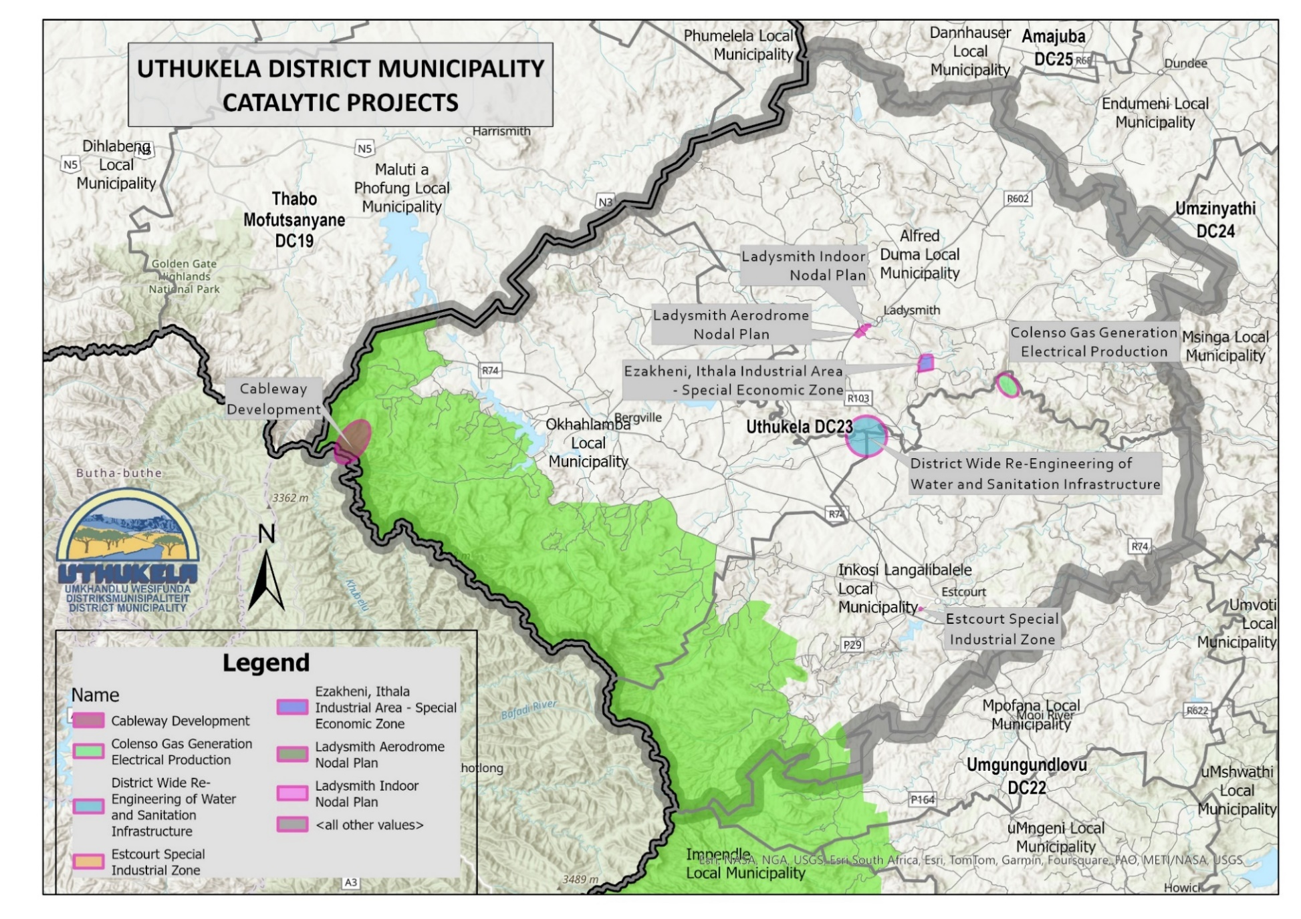Map 6:

Catalytic Projects

# Strategic Goals

Strategic Goals were developed for each Transformational Area and was articulated through the unpacking of the following:

* The Current Situation
* The Desired Future or vision
* Constraints
* The Strategies and Interventions needed to move from the Current to the Desired
* The Implementation Commitments by spheres of government and stakeholders
* Monitoring and evaluation measures by clusters

## Transformational Area 1: Demographic Change/People Development

**Diagnostics/Current Situation**

uThukela District has a total population of 789 092, with Alfred Duma LM having the highest population, followed by Inkosi Langalibalele LM and Okhahlamba LM. The District is female dominated, with 52.7% of households headed by females and 1 673 child-headed households. The dominated age group is 15-64 years old, and the majority population is African, with less than 5% made up of other groups.

Functional literacy rates and higher education attainment in the district is low and innovative programmes is needed with a focus on making education and resources more accessible and promoting the importance of education in communities.

The District unemployment rate is 44%, with youth unemployment at 60%. The high unemployment rates, particularly in the youth sector, indicates the lack of economic opportunities.

uMnambithi has the highest concentration of the population, which places a strain on the existing infrastructure as people move to uMnambithi for employment opportunities. The District has 37 fixed Primary Health Care (PHC) clinics and 14 mobile clinics. Alfred Duma has the highest number of clinics and Okhahlamba has the least.

**Desired Future/Vision**

By 2050, uThukela will be a multi-functional and skilled District which will improve the quality of life of people living in the District, focusing on vulnerable and marginalised groups.

**Constraints**

* Majority of the black communities are in townships, rural and tribal areas.
* Lack of substantial investment in human capital.
* Lack of educational facilities that accommodate the demand, or some areas do not meet the standard requirement threshold to warrant a school.
* Poorly maintained infrastructure and services.
* Limited access to social services.
* Increase in Gender-Based Violence (GBV) and Femicide

**Strategic Interventions**

* Develop skills development programmes and provide skills training that target the youth.
* Improve access to education and training from ECD to tertiary levels.
* Improve access to inclusive employment opportunities and entrepreneurships.
* Improve access to social services, e.g. healthcare, social grants through online applications, community outreach programmes, kiosk and guided applications.
* Improve the response and implementation of the National Strategy on Gender-Based Violence and Femicide (2020) in deal with GBV and Femicide

**Stakeholders**

* uThukela DM
* All LMs
* Department of Social Development
* Department of Basic Education and Department of Higher education
* SASSA
* Private Institutions
* Organised Business
* SAPS

**Monitoring by Clusters**

Social Cluster, ESID Cluster, Justice Cluster

## Transformational area 2: Economic Positioning

**Diagnostics/Current Situation**

One of the main District priorities is to reduce poverty and create jobs through growing of the local economy. This will require the District to position itself with the aim of attacking investment.

Key economic drivers include Manufacturing, Agriculture, Tourism, Wholesale and Retail and Transport. There is limited skilled labour, particularly in the male youth sector and employment opportunities are not enough for the population, both for the skilled and unskilled.

Inkosi Langalibalele is faced with rural poverty, where most of its settlements do not have access to economic and social development opportunities. Estcourt is well placed to become a major role-player in the economy, given its proximity to the N3, rail and the Wagendrift dam. The economy of Alfred Duma is well developed with uMnambithi as its major town having well-established and serviced areas for light-to-medium industries and commercial service centres.

**Desired Future/Vision**

By 2050, uThukela district will be a business-friendly environment that attracts local and regional investments, promotes the creation of business, and encourages skill development and business training.

**Constraints**

* High level of unemployment
* Lack of economic diversity and competitiveness of small towns
* Lack of infrastructure for new developments, e.g. water demand cannot be satisfied - Development is being up due to little investment in new infrastructure and a failure to maintain existing infrastructure
* Ageing infrastructure
* Inability to achieve a diverse economic and business attraction efforts have been minimal
* Lack of funding to stimulate development and to create an enabling environment

**Strategic Interventions**

* Invest in basic infrastructure (maintenance, operations and development) to address the developmental need and limit environmental damage.
* Work together with tertiary education and private sector to develop needed/targeted skills that are youth focused.
* Review the strategies contained in the Rural Development Plan.
* Support and unblock Catalytic Project implementation.
* Engage the tourism and agricultural sectors to strive for sustainability and transformation.
* SASSA providing income support to persons who are unable to support themselves and/or their dependents.
* Providing institutional platform for implementation of section 27 (1)(2)(c) and further create channels for eligible beneficiaries to access their social grants including Social Relief of Distress

**Stakeholders**

* COGTA
* EDTEA
* IDC
* All LMs
* Thukela DM
* Department of Sports and Arts and Culture
* Department of Agriculture, Land Reform and Rural Development.

**Monitoring by Clusters**

Social Cluster, ESID Cluster

## Transformational Area 3: Spatial Restructuring and Environmental Sustainability

**Diagnostics/Current Situation**

Land reform and access to affordable housing remains a pressing issue, with many previously advantaged Black Africans lacking secure land tenure or access to adequate housing. The District consists of three local municipalities and is positioned midway between Durban and Johannesburg, which is beneficial in terms of trade and commerce. It has a substantial portion of the Maloti-Drakensberg Park World Heritage Site located within the District, which is globally recognised, with the potential to grow the Tourism industry. The District has a range of sensitive areas, historical sites and catchments areas, which require protection and could be exploited.

The N11 joins the N3 outside of uMnambithi and is an important link to norther-KZN, Gauteng and Newcastle. There is also a railway line linking KwaZulu-Natal with Gauteng and Mpumalanga Provinces. There is an abundance of water within the District, the biggest river being the Tugela River, with notable dams such as the Spioenkop and Wagendrift dams.

The District has poor settlement patterns, because of past discriminatory policies, with many poorly serviced rural communities with limited economic and social opportunities, as well as Traditional Land, which makes up approximately 18% of the District.

**Desired Future/Vision**

By 2050, uThukela will be an inclusive, spatially and environmentally sustainable area that protects the environment, promotes spatial transformation, with equitable access to resources, services, and opportunities.

**Constraints**

* Budget constraints restricts the extent to which land can be obtained, restructured, developed or protected.
* Regulatory constraints, such as building codes, zoning laws, and other regulations may impose restrictions on what changes can be made.
* Factors such as structural integrity, utility/service connections, and access to resources can influence how a space can be developed.
* Deadlines, time-sensitive requirements and a lack of coordination may limit the pace of development.
* Input and approval from various stakeholders, such as owners, tenants, or community members, may impact the scope and timeline of the restructuring process.

**Strategic Interventions**

* Set clear goals and objectives for the spatial transformation of the District, e.g. Urban Edges, Land Audit, etc.
* Transform the Planners Forum to be an inclusive structure where stakeholders can collaborate early on in the developmental process to gather input, address concerns and build consensus.
* Review the Rural Development Plan to address the needs of disadvantaged rural communities.
* Prioritise the poor performance in terms of in Green Drop compliance.

**Stakeholders**

* All LMs
* uThukela DM
* Private Sector
* Community Organisations
* DALRRD
* COGTA
* Non-Governmental Organisations (NGOs)
* Farmers Associations

**Monitoring by Clusters**

ESID Cluster

## Transformational 4: Area Infrastructure Engineering

**Diagnostics/Current Situation**

A variety of infrastructure services within the district needs to be addressed. Road infrastructure to the District’s tourism offerings are in a poor state. A document was submitted to the PTIC and has been expanded upon by Department of Transport. The implementation of which should be monitored, and commitments secured.

Water and sanitation infrastructure are dilapidated and not well maintained and a complete overall of the water and sanitation networks and infrastructure is required. Backlogs in water and sanitation services are also still in existence and needs to be eradicated within the respective timeframes.

Issues around flooding and storm water management has been centre stage following the recent floods. Some storm water issues were identified as contributing to occasional flooding in Ladysmith.

**Desired Future/Vision**

By 2050, the uThukela District will have a well-maintained road network, a transformed water and sanitation system where all RDP targets have been realised and industries are confident of a steady supply of municipal services.

**Constraints**

* Lack of an Integrated Water and Sanitation Master Plan to address backlogs, capacity constraints, dilapidated infrastructure and maintenance constraints.
* Lack of funding to develop the Integrated Water and Sanitation Master Plan and the implementation thereof.
* Lack of funding to maintain municipal infrastructure and respond to ESKOM challenges.

**Strategic Interventions**

* Develop an Integrated Water and Sanitation Master Plan to address backlogs, capacity constraints, dilapidated infrastructure and maintenance issues.
* Aligning the WSDP with the Integrated Water and Sanitation Master Plan.
* Align budget and grants to implement the WSDP / Integrated Water and Sanitation Master Plan.
* Finalise Action Plans to Address Flooding in Alfred Duma LM and prioritise implementation.
* Department of Transport to align budget and provide updates on the maintenance and upgrading of Tourism infrastructure.
* SASSA to provide temporal relief to persons in crisis such as disasters.

**Stakeholders**

1. uThukela DM
2. Alfred Duma LM
3. Okhahlamba LM
4. Department of Transport
5. DWS
6. COGTA
7. SASSA
8. uMngeni-uThukela Water

**Monitoring by Clusters**

ESID Cluster

## Transformational Area 5: Integrated Service Provisioning

**Diagnostics/Current Situation**

Backlogs experienced in all areas of basic service delivery and infrastructure maintenance, the most affected being people living in rural areas. The municipality is experiencing challenges due to poor and ageing infrastructure, especially water and sanitation infrastructure. Some rural areas have limited access to electricity and there are several rural areas that lack access to appropriate sanitation facilities and are suffering from constraints in access to water.

The development and maintenance of social services and facilities is important for the overall well-being of uThukela residents. Access to social facilities is often limited in rural areas, due to constraints in physically access to service due to a lack of public transport or the unavailability of services such as education, healthcare and Social Security. There is a general limitation of social services in rural areas.

**Desired Future/Vision**

By 2050, uThukela residents will experience quality service delivery, a decrease in backlogs, and an increase in equitable access to services and other socio-economic opportunities.

**Constraints**

* Poor infrastructure maintenance.
* Lack of funding to maintain and expand infrastructure and social services in previously disadvantaged communities.
* Inconsistent government service delivery levels and standards.
* Lack of funding to address service backlogs

**Strategic Interventions**

* All Ward Committees, DDM Clusters and OSS Structures to be functional and effective.
* DDM Clusters to become the driving force in resolving grassroots issues.
* Develop an all-inclusive, long-term Strategy to bring services to the people, particularly in rural areas.
* SASSA will render a Service Delivery Outreach Programme in a one stop integrated manner with sister Departments to enable access to government services.

**Stakeholders**

1. uThukela District Municipality
2. Alfred Duma LM
3. Okhahlamba LM
4. Inkosi Langalibalele LM
5. Department of Transport
6. Department of Health
7. Department of Education
8. South African Social Security Agency (SASSA)

**Monitoring by Clusters**

Social Cluster/ESID Cluster

## Transformational Area 6 – Governance and Management

**Diagnostics/Current Situation**

In general municipalities are struggling with financial constraints and audit outcomes, which has an impact on service delivery, general performance and service delivery. In uThukela, most of the protest action revolves around water and sanitation service delivery, which reflects as poor governance. OSS War Rooms are established, but with a wide range of functionality issues and constraints.

**Desired Future/Vision**

By 2050, Municipalities will be well functional institutions, that are in a sound and stable financial position, obtaining clean audits with a high approval rating by their clients. War Rooms will be capacitated, funded and functional, making an impact in the lives of their citizens.

**Constraints**

1. Budget and revenue collection
2. UIFW – Unauthorised, Irregular, Fruitless and Wasteful Expenditure
3. Training of personnel on War Room operations
4. OSS War Room functionality not integrated into Clusters
5. Lack of War room space
6. Commitment on the part of the leadership and Management
7. Change of Political Leadership
8. War Room not support by municipalities (budgets, maintenance and responses)
9. Absence of deployed Senior Management Services (SMS) members in the War Rooms

**Strategic Interventions**

* Increase revenue collection rate to above 50%
* DM and LMs to realise 100% grant expenditure and all grants to be cash backed by 2030
* Establish a CFO’s Forum
* All LMs to strive to an Audit Finding of at least “Unqualified with Findings” by 2030
* Unresolved War Room Issues to be elevated to Cluster meetings

**Stakeholders**

* All LMs
* uThukela DM
* Office of the Premier
* KZN COGTA
* Auditor General

**Monitoring by Clusters**

Governance Cluster

# Implementation, Monitoring, and evaluation

The purpose of monitoring and evaluation is to assess the track implementation of projects and programmes and established the impact of such. Monitoring provides detailed information on activities and where improvements can be made while evaluation performance and progress towards a completed product.

## Monitoring and Evaluation

It is anticipated that the Clusters will monitor the above interventions per Transformational Area, as well as Catalytic Project implementation.

Issues raised during Cluster meetings cannot be accommodated in the One Plan, as it will be impossible to anticipate and predict interventions. It is therefore advised that issues raised, and subsequent actions be thoroughly documented to be reported back at the next meeting. For these purposes detailed actions and resolutions will have to be captured by the secretariat for each Cluster and a mechanism be put in place to elevate unresolved actions.

For the ease of monitoring and evaluation, a basic Implementation table will be utilised to guide Clusters in which matters to receive a report on. For the monitoring and evaluation to occur fruitfully, the following processes will be undertaken:

* + Develop a performance management system in the form of an Implementation Table.
  + For each Strategy, I lead person will be identified, followed by a list of Stakeholders and their contributions, followed by a column for the due date and progress.
  + The implementation of the DDM One Plan will be published annually.

Table 13: Monitoring Elements per transformational area

|  |  |  |  |  |  |  |  |
| --- | --- | --- | --- | --- | --- | --- | --- |
| Cluster |  | Strategy | Lead Person | Stakeholders | Stakeholder Actions | Due Date | Progress |
|  |  |  |  |  |  |  |  |

## Key Performance Indicators and Targets*

Table 14: Outcomes, Outputs, Key performance indicators and targets

| **Cluster** | **Key Issue** | **Strategies & Programmes** | **Lead Person** | **Stakeholders** | **Objectives** | **Due Date** |
| --- | --- | --- | --- | --- | --- | --- |
| **Transformational Area 1 – Demographic Change/People Development** | | | | | | |
| ESID | 1. Youth Education and Development | Develop skills development programmes that are relevant and provide skills training that target the youth. | UEDA | SETA  EDTEA  UEDA  LED units (LMs & DM)  Business Chamber | To develop and fund a Youth Training Programme | 31 December 2025 |
| Social | 1. Poor access to education and training - ECD to Tertiary Levels | Improve access to education and training from ECD to tertiary levels.  To improve the teacher/student ratio | Department of Education | Dept. of Education and Dept. of Social Dev. | To build more education facilities and reduce overcrowding in classes | Quarterly  Reports |
| ESID | 1. High unemployment levels | Improve access to inclusive employment opportunities and entrepreneurships. | UEDA | UEDA  EDTEA  Dept. of Labour  LED units (LMs & DM)  Business Chamber | To reduce the levels of employment | Quarterly  Reports |
| Social | 1. Poor access to Social Services | Improve access to social services, e.g. healthcare and social security | Dept. of Social Development | Dept. of Social Dev.  Dept. of Health  Dept. of Home Affairs  SAPS  SASSA  DM and LMs | To bring services to the people, particularly in rural and previously disadvantaged areas | Quarterly Reports |
| Justice | 1. Gender-Based Violence and Femicide | Improve the response and implementation of the National Strategy on Gender-Based Violence and Femicide (2020) in deal with GBV and Femicide | Dept. of Social Development | Dept. of Social Dev.  SAPS  POWA (People Opposing Woman Abuse)  Community Leaders  Organised Groups | To implement the National Strategy on Gender-Based Violence and Femicide (2020) | Quarterly Reports |
| **Transformational Area 2 – Economic Positioning** | | | | | | |
| ESID | 1. Targeted Skills Development | Work together with tertiary education and private sector to develop needed and targeted skills that are youth focused. | DOE - District Manager | DM & LMs  DOE  TVET  UEDA  Business Chamber | To develop a database of skills needed by organised business, investors and industries | Quarterly |
| ESID | 1. A lack of Development in Rural Communities | Review the strategies contained in the Rural Development Plan. | KZN Dept. of Agriculture & Rural Development | KZN DARD  DM & LMs  EDTEA  ADA  Ingonyama Trust Board  UEDA  COGTA | To increase Rural Development and job creation | Quarterly |
| ESID | 1. Catalytic Projects are not implemented | Support and unblock Catalytic Project implementation. | Cluster Chair to facilitate | ALL as per commitment | To stimulate sustainable development, job creation and the transformation of the District | Quarterly |
| ESID | 1. Lack of Transformation in the Agricultural and Tourism sectors | Engage the tourism and agricultural sectors to strive for sustainability and transformation. | KZN EDTEA &  KZN DARD | EDTEA  KZN DARD  UEDA  ADA  DM & LMs  COGTA  CTOs | To gain an understanding of the constraints and appoint suitable mentors to transform the sectors | Quarterly |
| **Transformational Area 3 - Spatial Restructuring and Environmental Sustainability** | | | | | | |
| ESID | 1. Lack of Spatial Transformation | Set clear goals and objectives for the spatial transformation of the District, e.g. Urban Edges, Land Audit, etc. | COGTA | COGTA  DM & LMs  KZN DARD  EDTEA | To see a Spatially Integrated District that does not reflect the segregatory form | Quarterly Reports |
| ESID | 1. Lack of Alignment in the Development Processes | Transform the District Planners Forum to an inclusive structure where stakeholders can collaborate early in the developmental process to gather input, address concerns and build consensus. | DM Manager  Planning & GIS | UTDM  All LMS  Developers  UTDM & LMs Technical Services | To realise coordination and synergy in the development process | Q3 – 2024/25 |
| ESID | 1. Non-functional Waste Water Treatment Works | Develop a Strategy and address the poor performance in terms of in Green Drop compliance | DM Technical | DM Technical  uMngeni-uThukela Water  COGTA  DWS  EDTEA | To mitigate environmental pollution | Quarterly |
| **Transformational Area 4 - Infrastructure Engineering** | | | | | | |
| ESID | 1. Water and Sanitation Backlogs | Develop an Integrated Water and Sanitation Master Plan to address backlogs, capacity constraints, dilapidated infrastructure and maintenance. | uMngeni-uThukela Water & DM Technical | uMngeni-uThukela Water  DM Technical  DWS  COGTA | To provide access to clean water, functional sanitation and a healthy environment to all | To be advised |
| ESID | 1. Poor and ageing municipal infrastructure | To develop/update maintenance plans per municipal infrastructure sectors | DM Technical | uMngeni-uThukela Water | To provide functioning systems for maintaining of municipal infrastructure as per Municipal Infrastructure Maintenance Plans | To be determined |
| Justice | 1. Flooding of uMnambithi following prolonged rain | Finalise Flood Mitigation Plan to address flooding in uMnambithi and prioritise implementation. | AD LM | AD LM  COGTA  DWS | To mitigate the impact of floods in uMnambithi | To be determined |
| Governance | 1. Poor state of tourism infrastructure and District Roads | Department of Transport to align budget and provide updates on the maintenance and upgrading of District Roads and routes leading to tourism offerings | KZN DOT | KZN DOT  EDTEA (PTIC)  DM & LMs  CTOs | To have a safe and well maintained District road network serving the District and District tourism destinations | Quarterly Reports |
| ESID | 1. Need for Social Housing | Housing Need Analysis and Strategy to address the housing need | Dept. of Human Settlement | Dept. of Human Settlement  ALL LMs | To provide safe and serviced Social Housing to communities | To be determined |
| ESID | 1. Alternative sources of energy | Explore the use of alternative sources of energy. Facilitate the Colenso Gas Project | uTDM, ADLM & ILM | Colenso Gas  TIKZN  COGTA  Dept. of Mineral Resources & Energy  EDTEA  DM & All LMS | To maximise energy production, minimise environmental degradation and address backlogs | End 2025 |
| ESID | 1. Limited scope of operations of the uMnambithi airfield | To review the scope and functionality of operations as a District Airfield | AD LM | AD LM  COGTA  EDTEA | To enhance the efficient connectedness of the District | To be determined |
| Justice | 1. Poor Storm Water Management resulting in seasonal floods | To establish a functional Storm Water Management System | AD LM | AD LM  COGTA  DWS | Efficient and effective storm water management and flood mitigation | To be determined |
| ESID | 1. Lack of effective and sustainable provision of service to stimulate investor confidence | Develop and implement investment strategy for the District | UEDA | UEDA  DM  All LMs  TIKZN  EDTEA COGTA | To enhance investor confidence through sustainable service delivery | To be determined |
| Governance | 1. Vandalism of infrastructure | Improve physical security and mitigate vandalism through awareness campaigns in communities | DM & All LMs | DM  All LMs | To mitigate infrastructure vandalism | To be determined |
| **Transformational Area 5 - Integrated Service Provisioning** | | | | | | |
| All | 1. Grassroots issues are not always resolved satisfactory | DDM Clusters to become the driving force in resolving grassroots issues. | ALL Cluster Chairpersons | All Cluster members | To have grassroots issues resolved speedily and satisfactory | Every meeting |
| Social | 1. People have to travel long distance for government services | Develop an all-inclusive, long-term strategy to bring services to the people, particularly in rural areas. | SASSA | SASSA  DALRRD  DM & LMs  All DDM Members | To establish service centres within communities | Quarterly |
| Social | 1. Functionality of the Rapid Response Teams | Ensure the Functionality of the Rapid Response Teams | COGTA | All Stakeholders | To have functional Rapid Response Teams to respond efficiently and effectively to emergencies and service delivery backlogs | Quarterly |
| **Transformational Area 6 - Governance and Management** | | | | | | |
| Governance | 1. Poor collection rate | Increase revenue collection rate to above 50% | ALL CFOs | DM & LMs | To steadily increase the collection rate | 30 June 2026 |
| Governance | 1. Grants not cashed backed and expenditure below 100% | DM and LMs to realise 100% grant expenditure and all grants to be cash backed by 2030 | All Technical Dept. & CFOs | DM & LMs | To have all grants cash backed and expenditure to be at 100% | 30 June 2026 |
| Governance | 1. Lack of municipal financial coordination | Establish a CFO’s Forum | DM CFO | DM & LMs | To gain financial knowledge and support across municipalities | 31 March 2025 |
| Governance | 1. Lack municipal financial coordination | Municipal Audit Action Plans  CFO's Forum to advise on Audit Findings  DM & LMs to strive towards an Audit Finding of at least “Unqualified with Findings” by 2030 | DM & LMs | DM & LMs  AG | For all LMs to have an Unqualified Audit Finding | 30 June 2025 |
| Governance | 1. Commitment by Leadership | Functionality of municipal structures (Council, EXCO, Portfolios, etc.) | DM & LMs | DM & LMs | Improved oversight from leadership and development support | Quarterly |
| Governance | 1. Continued Section 139 Interventions | Resolving Section 139 interventions | COGTA | Municipalities affected | To move all municipalities out from under Section 139 Intervention | Quarterly |
| Governance | 1. Traditional Leadership not fully represented | Training of Traditional Leadership on local governance management.  Participation of traditional leaders | DM & LMs | DM & LMs Traditional Authorities | To have Traditional Leadership participate in municipal Structures | Quarterly |
| Governance | 1. War Rooms not functional | Training of personnel on War Room operations  Quarterly reports on War Room functionality  Elevate unresolved issues to Clusters | District Task Team Chairperson | Provincial Task Team  District Task Team  Local Task Team  War Rooms (Ward Task Teams)  Community Caregivers  Communities | Functioning Ward Committees and War Rooms | Quarterly |
| Governance | 1. Unbudgeted functions, lack of support and mentoring of municipalities | Capacitate Municipalities in a meaningful manner to provide their functions | COGTA | COGTA  Office of the Premier  Municipalities | Meaningful support and mentoring of municipalities | 31 March 2026 |
| Governance | 1. Lack of consequence management | Re-evaluation of consequence management processes and procedures to be strengthened | Municipalities | SALGA  MPAC  Municipal Council  Municipal Managers | To strengthen sound accountability processes | 30 June 2026 |
| Governance | 1. Absence of deployed SMS (Senior Management Services) members | Improved oversight and interventions from SMS members | Dept. of Public Services and Administration | Dept. of Public Services and Administration  Municipal Managers  Managers reporting to the Municipal Manager | Improved oversight and interventions from SMS members | 30 June 2026 |

# Conclusion

The uThukela District One Plan has opportunity for various stakeholders to participate and contribute towards the desired future as indicated in the One Plan Vision. It is a living breathing document, subject to constant input from Clusters and other Stakeholders and subject to annual review. The role of community-based stakeholders and the private sector cannot be overemphasised in the continuous review and implementation of the One Plan, which goes hand in hand with Cluster functionality.

The purpose of the DDM and One Plan is broadly three-fold, namely: 1. To ensure the implementation of Catalytic Projects, 2. To monitor the transformation of the District in terms of the six Transformational Areas and 3. To ensure an integrated response to grassroots issues as raised by communities. Only through functional DDM Structures can we change people’s lives and ensure that the One Plan is resourced, implemented, and monitoring.